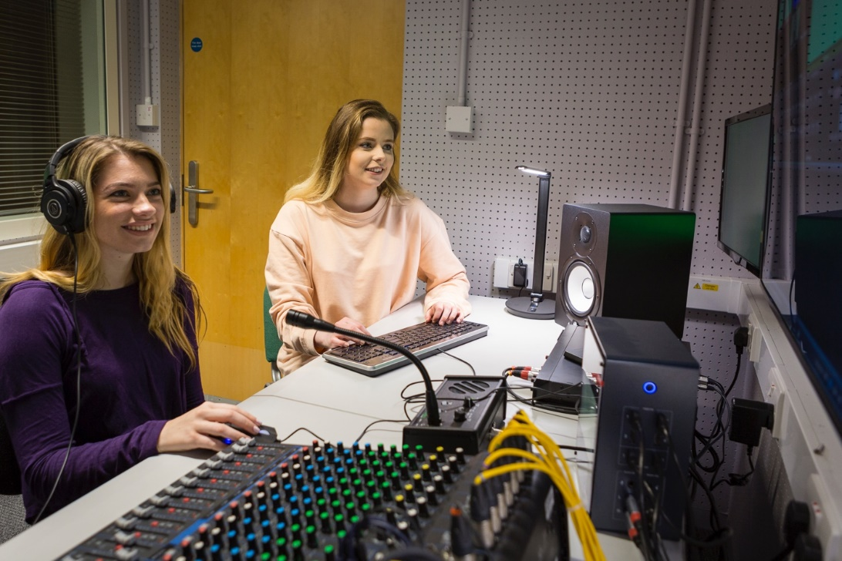

Image: University of Roehampton

**Connecta**

**LEARNING PACK 7 |**

**ADDING SPECIAL EFFECTS, SOUND AND MUSIC**





**Contents**

1. The importance of sound and music 1
2. Types of audio recordings 1
3. Lightworks tutorial 1

Special effects 1-4

Creating text 4-7

Creating an effects track 7-8

Creating transitions 8-11

Adding sound and music 11-12

Mixing audio 12-13

Creating an audio fade 13-14

Creating sequences 14-16

Exporting your finished video 16-17

1. Syncing 18
2. Glossary 18-19
3. Self-assessment 19
4. References 20

**1. The importance of sound and music**

When working with learning pack 1 on accessible film making, you will have noticed that watching audiovisual content with the sound on mute limits your experience of the text. This is because film is an audio and visual medium, meaning the sounds you hear are just as important as the video you see. It is important not to overlook the element of sound as a film is not complete until sound has been properly integrated with the video.

**2. Types of audio recordings**

Hopefully, you have been able to record sound on a separate device and select audio tracks to go with the video you shot on your camera. Ideally, you will have sounds in the following categories:

* Dialogue recorded within a take
* Ambient sounds, or background noise
* Separate sounds taken without video

The goal is to take these sounds and integrate them into your video clips so they become one. To do this, you will need to get them in order and find out where they should go in your edit.

**3. Lightworks tutorial**

Just as in learning pack 6 on editing, we have created a short user guide to help you add special effects, sound and music to your video clips and images on the editing software Lightworks. These steps apply to Mac, Windows and Linux computers.

**Special effects**

|  |
| --- |
| **Special effects**   * To add an effect to a clip, make sure that the vertical red line is on the clip you want to add the effect to. * Then, go to the ‘VFX’ tab at the top-centre of the window. * When you are in the ‘VFX’ tab, you will see your clip in the media viewer, as well as the colour corrections panel on the left, underneath the ‘Settings’ tab. * There is also a timeline on the bottom-right. This timeline is the same timeline as the one in the ‘Edit’ tab. |
|  |
| Take a few minutes to play around with the colours, using the colour wheels and colour correction sliders to see how they affect the look of your clip. |

|  |
| --- |
| Once you’ve had a look at what the colour wheels and sliders can do, click on the gears  icon in the top-right corner, this will give you a drop-down menu.   * Select ‘reset’ * Select ‘All’ * This will reset all settings back to the original |
|  |

|  |
| --- |
| To the left of the ‘Settings’ tab you will see a ‘+’ sign. If you click on this sign you will see a list of pre-set effects that you can add to your clips. |
|  |

|  |
| --- |
| * If you go to the right-hand corner (in the same position as the gears icon) you will see ‘Favourites’ and arrow pointing downwards. * Click on the arrow to see a drop-down menu. * You will have the option to select a specific category of effect, such as ‘Colour’, ‘Text’, ‘Plugins’ etc. * Once you have selected a category and you find an effect that you like within that category, double click on the effect and it will be applied to your clip, which you’ll be able to see on the media viewer. * Once you have doubled clicked on an effect, you will be reverted back to the ‘settings’ tab and a control panel corresponding to the effect you have selected will appear below. For example, in the image below we have selected the ‘Text’ category, then the ‘Titles’ effect. |
|  |
| * If you decide that you no longer want to use that effect, again, click on the gears  icon in the top-right corner * Then click ‘reset’ * Then click ‘All’ in the drop-down menu |

|  |
| --- |
| Now you can click the ‘+’ sign again to view different effects.  (Tip: You can also add effects that you want to use frequently to the ‘Favourites’ category, by clicking the  symbol beside the name of the effect, when it turns to yellow , it has been added to the favourites). |

**Creating text**

|  |
| --- |
| **Creating text**  If you want to use a text effect, go to the drop-down menu on the ‘Settings’ tab and select the ‘Text’ category. |
|  |

|  |
| --- |
| To add opening title credits to the video:   * Go to the ‘Titles’ effect in the ‘Text’ list, double-click on ‘Titles’ * The words ‘Sample Text’ will appear over the clip in the media viewer * Now you can type any words or symbols you like in the box in the control panel |
|  |
|  |

|  |
| --- |
| * When you have selected the ‘Titles’ effect, you will see the text control panel under the ‘Font’ tab, such as ‘Typeface’ (font type), **Bold**, *italic*, size and opacity. * If you click on the ‘Face’ tab, you have options to change the colour of your text. You’ll also have the option to use the ‘Colour Picker’  . * The ‘Colour Picker’ allows your text to mimic any colour on the screen, including the media viewer, by hovering over any colour and clicking on it. |
|  |
|  |

|  |
| --- |
| The next tab is the ‘Position’ tab, this tab lets you move your text around the screen when you move slider ‘X’ or slider ‘Y’.  (Tip: Alternatively, you can just click on the text in the media viewer and drag it around the screen.) |
|  |
| Please take the time to try various effects and alter them in the control panel.  Remember, if you want to revert back to the original, click on the gears  icon in the top-right corner and then ‘reset’, then ‘All’ in the drop-down menu. |

**Creating an effects track**

|  |
| --- |
| **Creating** **an** **effects** **track**  If you want to create an effect on its own independent track and not over a video clip, follow the steps below:   * Move the vertical red line in the timeline to a blank area where there are no clips, you will know this because the screen on the media viewer will be black. * Now repeat the steps used to create a title. Then, go back to the ‘Edit’ tab to see that the effect has its own track under the name ‘FX1’ just above the video track. |
|  |
| Tip: Now that the effect has its own track, you can hover over the edges until you see white brackets, click on the brackets to make it turn yellow and either trim it to make it shorter or stretch it to make it longer depending on your needs. |
|  |

**Creating transitions**

|  |
| --- |
| **Creating transitions**  Transitions are an important tool that editors use to cut smoothly from one scene to another. For example, a scene will fade out of the screen and another scene will fade into the screen. Follow the steps below to create a transition:   * Make sure the vertical red line is on the clip you want to have the transitions effect or create its own track on the timeline. * Click on the ‘+’ sign on the left side of the ‘Setting’ tab or click on ‘Mix’ in the drop-down menu. * You’ll now have a list of transitions, in this example we will select the ‘Dissolve’ effect. |
|  |

|  |
| --- |
| * Once you double-click on the ‘Dissolve’ effect, a panel will appear on the left with a slider. |
|  |

|  |
| --- |
| * The slider represents the opacity of the dissolve, which by default will be around 50%. However, it may be lower depending on if your video features a lot of dark colours, particularly black. * Without adjustments, the dissolve effect will be applied throughout the whole clip. So, if you play the clip, it will look normal then slowly fade to a darker image, but not completely black. * You may want the clip to start off completely black, then fade in to the clip. * Just above the ‘Dissolve’ panel there is a tab titled ‘Graphs’. * Select this tab and you’ll see a rectangle with a horizontal line and a diagonal line in the control panel. |
|  |
| * The top of the graph is 100% black, and the bottom is 0% black, so the default setting sets your clip to start at 0%, then slowly fads to black over the entire length of the clip. |

|  |
| --- |
| * To start the clip with black, click on the left edge of the diagonal line and drag it to the top. This sets the beginning of the clip to 100%. * To do the opposite on the other side, click on the right edge and drag that side all the way to the bottom. This sets that side of the clip to 0%. |
|  |

|  |
| --- |
| * Now click on ¼ of the length to the left side of the diagonal line so it makes a circle on the line, then drag this point all the way down to the bottom. |
|  |
| * The start off the clip now begins completely black, then quickly fades into the picture. |

|  |
| --- |
| * By clicking on certain parts of the diagonal line, then adjusting and bending that line as well as its endpoints, you can adjust when, where, and how quickly the black dissolves in or out. * If you want the same clip to end fading to black, just add another dissolve effect to the same clip. A new ‘Dissolve’ control panel will appear above the old one. You just need to repeat the steps above. |
|  |
| * Now, the clip will fade in at the beginning and fade out at the end. |

**Adding sound and music**

|  |
| --- |
| **Adding** **sound** **and** **music**  Adding sound and music is the same as adding video. If you already have sound embedded with your video, you can use to following steps to add only music:   * Go to the ‘Log’ tab in the top-centre and click on ‘Places’ to find the location of your sound and music files. * Double click on each file and when the files are imported, it will say ‘Imported’ beside the file. * Go to the ‘Edit’ tab, here you will see there will already be space to add the audio on track ‘A1’ to ‘A2’ if you don’t have sound embedded with your video. * If you do, add additional sound (like music) to tracks ‘A3’ to ‘A4’. * Remember, if you want to add additional tracks, right click on the left of the timeline, go down to ‘Tracks’ and select ‘Add audio’ or ‘Add video’. * Once you have audio on your tracks you can trim them in accordance to the length of you video files. |

**Mixing audio**

|  |
| --- |
| **Mixing audio**   * To get started with audio mixing, go to the ‘Audio’ tab by clicking on the top-centre of the window. * You should now see all your audio clips down on the timeline, with the video track/s above minimalised. |
|  |

|  |
| --- |
| * In the top right corner of the window, there is a panel with audio bars. If you click play on the media viewer you’ll see the audio bars move up and down in accordance to the various levels of sound coming from the clip. * Underneath the sound bars, you’ll see five names representing each sound bar, such as: ‘A1’, ‘A2’, ‘A3’, ‘A4’ and ‘LR’. * ‘A1’, ‘A2’, ‘A3’ and ‘A4’ if you remember, were also the names of the audio tracks in the ‘Edit’ tab. These are the same audio tracks. * You can now adjust the sounds levels by clicking between to two blue triangles  and dragging them upwards to raise, or downwards to lower each track. * The ‘LR’ track stands for ‘left’ and ‘right’, this represents all the audio together and gives you the overall audio levels in your video. * Clicking between the blue triangles and dragging these upwards or downwards will either raise or lower the overall sound levels.   (Tip: A more basic way of adjusting the sound levels for a track is to move your mouse cursor over to the timeline at the bottom. There will be a white dotted line that goes across each audio track, with a white square appearing when you move your mouse cursor on the track). |
|  |
| * Click on the centre area of this line and hold, you can drag this line upwards or downwards. This line represents the audio levels of the selected audio track. |

**Creating an audio fade**

|  |
| --- |
| **Creating** **an** **audio** **fade**  You can make audio fade in and out just as you did with the video, here’s how:   * Hover your mouse cursor over the top-left corner of the audio clip on the timeline – you will see a triangle shape appear. |
|  |

|  |
| --- |
| * Drag the triangle right to create a diagonal line moving with your cursor. |
|  |

|  |
| --- |
| * Once you’ve moved the triangle to the right, click play on the media viewer and see how the fade sounds. * The diagonal line represents the increase in sound to your clip, the shallower the line, the longer it will take for the sound the raise in your clip. * Remember, if you don’t like what you’ve created, hold command or ctrl and press ‘Z’ to undo. * In the top-left corner of the window there will be a list of effects (if you do not see a list, click on the ‘+’ sign). * To add an effect to an audio clip, double-click the effect in the list, just like you did with the video effects. |

**Creating sequences**

|  |
| --- |
| **Creating sequences**   * In the top-left corner of the media viewer you will see the text ‘Sequence # 1’. * A sequence is a section of video that you’ve put together and edited into a completed segment. This can be a single scene or a completed video of connected scenes. * By separating scenes into sequences, Lightworks 14 allows you to use scenes as separate units. * This means that you can have a complete edited chase scene and move the scene around to any place you want it to appear in the final video, or even use different versions of it in multiple places within the whole video.   To create a new sequence:   * Go to the ‘Edit’ tab. * On the left of the project contents bin, you’ll see a ‘Filters’ menu. Below that menu, you’ll see the options ‘Clips’, ‘Subclips’, ‘Sequences’ etc. click on ‘Sequences’. * You will see ‘Sequence #1’ in the list of sequences, by default this is the name of the sequence you have been currently working on. |
|  |

|  |
| --- |
| * Right-click on the sequence section area to open a menu. When you see this menu, select ‘Make’, then select ‘Empty Sequence’ and a new sequence thumbnail should appear. |
|  |

|  |
| --- |
| * Double-click on the new sequence thumbnail and blank timeline will appear. Now you can add some new media files and start building a new scene. * By giving each sequence its own timeline, Lightworks 14 allows you to keep each of your scenes separate from one another, letting you to work on one scene at a time and allowing you flexibility of where to place each scene. * (Tip: If you drag and drop ‘Sequence #1’ into the new timeline, you are creating a copy of that sequence. Now you can change and alter that copy without affecting the original that’s stored in your sequence bin as ‘Sequence #1’). * Once all sequences are completed, create one final sequence. Then, drag and drop all your sequences together into the single timeline to create a finished video. |

**Exporting** **your** **finished** **video**

|  |
| --- |
| **Exporting** **your** **finished** **video**  When you have finished editing your video, you must export it, so your video can be viewed outside the editing software:   * To begin exporting, click on the ‘Sequences’ option under ‘Filters’. * Then, hover over a blank space in your timeline below. * Right-click and select ‘Sequence Commands’, then ‘Export’. * A list of more options should appear, select ‘H.264/MP4’ from the list. |
|  |

|  |
| --- |
| * An export panel will now appear in place of the media viewer. |
|  |

|  |
| --- |
| * This panel will allow you to select the format, the frame rate, size (resolution) and the destination of the folder for the export. The highest resolution for the export is 720p. * Once you’ve chosen your desired settings, select ‘Start’ at the bottom of the panel and the progress of the export will appear. |
|  |

|  |
| --- |
| (Tip: You can click on the small arrow on the top of the progress panel to hide the panel. The export will continue in the background, so you can edit more if needed).    This covers the beginner’s guide for using Lightworks 14. We are sure you will also learn how to use this software with ease by exploring it. An important part of video editing is experimenting, and it is fine to make mistakes because that’s how you learn.  The Lightworks 14 download also comes with a detailed user’s guide, so you’ll have everything you need to begin editing your film. |

**4. Syncing**

* Most of your audio will need to be paired with its video equivalent, which is referred to as syncing. To sync the audio with your video, you must view the video of your characters talking and match the audio with the motion of their lips.
* One action that might make this task easier, is if you created and used a clapperboard before every take that was shot.
* If someone in your group called out the name of the scene, the number of the take and the description of the shot before each scene, you may be able to sync the details of the clapperboard with the matching details in the audio.
* Another action that can make this easier, is if you also recorded sound on your camera. Looking at the pattern of the wavelengths (the wavy lines on the audio track) from the camera recording and matching it with the wavelengths of the recording from your separate device can help you find the right audio track to go with your video.

**5. Glossary**

|  |  |  |  |
| --- | --- | --- | --- |
| **English** | **Español** | **Français** | **Deutsch** |
| Special effects | Efectos especiales | Effets spéciaux | der Spezialeffekt  die Spezialeffekte |
| Text | Texto | Texte | der Text |
| Title | Título | Titre | der Titel |
| Effects track | Efectos de pista | Piste d’effets | die Spur für Spezialeffekte |
| Transitions | Transiciones | Transitions | der Übergang  die Übergänge |
| Audio fade | Fundido de audio | Fondu sonore | Ton einblenden/ ausblenden |
| Sequences | Secuencias | Séquence | die Sequenz  die Sequenzen |
| Export | Exportar | Exporter | importieren |
| Graphs | Gráficos | Graphique | die Grafik/ die Grafiken |
| Sound | Sonido | Son/Audio | der Ton |
|  |  |  |  |
|  |  |  |  |
|  |  |  |  |
|  |  |  |  |
|  |  |  |  |

**6. Self-assessment**

After completing the four exercises, tick the column that best represents how you feel about the following statements:

|  |  |  |  |
| --- | --- | --- | --- |
|  | **Not at all confident** | **Nearly there** | **Very confident** |
| 1 I understand the importance of sound in video editing |  |  |  |
| 2 I know what types of audio recordings I need for an editing |  |  |  |
| 3 I know how to use the video editing software Lightworks for adding special effects and mixing sound |  |  |  |
| 4 I know how to export a completed film |  |  |  |
| 5 I am aware of what to look for when syncing sound |  |  |  |

**7. References**

* Keet, J. (2018). *How to Use Lightworks 14 for Beginner Video Editors*. [online] TEACHER'S TECH. Available at: http://teachers.tech/ [Accessed 16 Feb. 2019].
* Lightworks. (2018). EditShare LLC.