

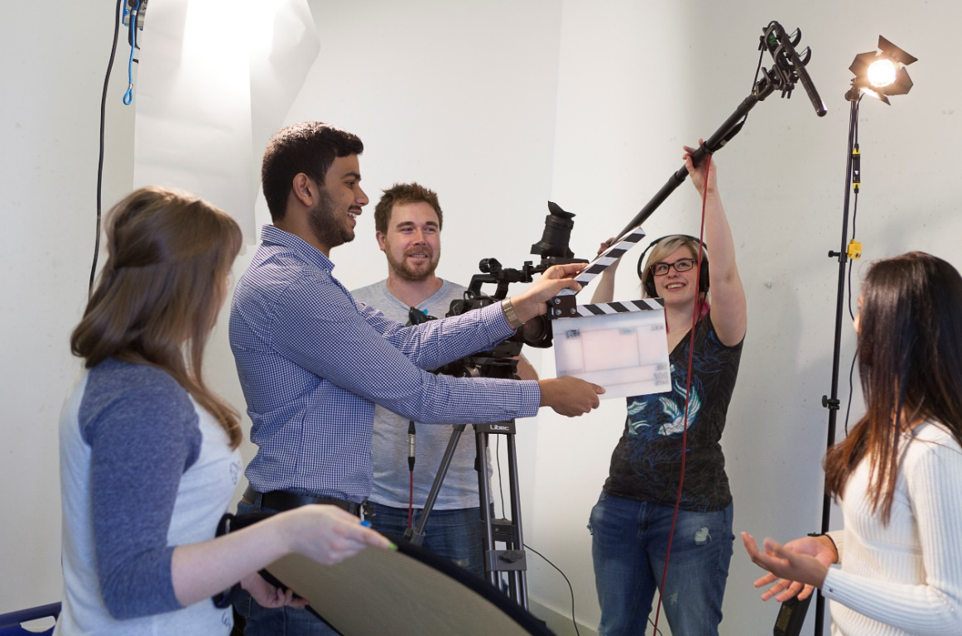

Image: University of Roehampton

**Connecta**

**LEARNING PACK 4 | ACTING**





Contents

1. Introduction 1
   1. Exercise 1 2
   2. How can I improve my acting? 2-4
2. Conveying emotion 4
   1. Exercise 2 4-5
   2. Exercise 3 5-6
3. Rehearsal 6
   1. Exercise 4 6
   2. Exercise 5 6-8
4. Monologues 8
   1. Exercise 6 9
   2. Exercise 7 9
5. Glossary 10-11
6. Self-assessment 11
7. References 12
8. **Introduction**

E0, Q1: To start, what do you think acting is? How would you describe it using key words that you have seen for accessible filmmaking, screenwriting and storyboarding?

Acting is the art or practice of representing a character on stage or before cameras. You will be already be familiar with actors such as: Will Smith, Asa Butterfield and Daniel Radcliff; and actresses such as: Gina Rodriguez, Willow Smith and Milly Bobby Brown.

Actors star in TV series, films and commercials and aim to tell a story to entertain the audience. In commercials actors must tell a story to sell a product or a service. It is essential for actors to develop good acting techniques to make their performance authentic. Good acting takes a lot of practice and actors attend a lot of auditions. Throughout this learning pack, we will explore some tips and tricks for good acting by exploring eye contact, facial expression, conveying emotions and delivering speeches.

To begin, watch this clip on why actors like to act and answer the questions below:

[Why actors like to act](https://www.youtube.com/watch?v=Ul_wE953yPQ)

E0, Q2: Who is your favourite actor/ actress and what film do you prefer of theirs?

E0, Q3: Who will you be taking inspiration from to create your film and why?

**1.1 Exercise 1**

Search for the following clip on YouTube:

* Friends – HD – Joey’s toast to Chandler and Monica

This clip shows Joey delivering a speech at Monica and Chandlers wedding. Throughout the series of Friends, Joey is constantly trying to find his big break as an actor. Joey realises one of the wedding guests is a film director, so he decides to show off his ‘acting skills’ in his toast to the bride and groom. The clip is ironic because he is trying to show off what he perceives to be good acting skills, but everyone knows they are poor!

E1, Q1: Watch the clip and note below how Joey shows each emotion.

Anger:

Happiness:

Sadness:

Fear:

**1.2 How can I improve my acting skills?**

Read through the following tips and think about how you can incorporate them into your acting:

**Eye contact**

Dos

* Show emotion through your eyes. If you smile, try to make your eyes appear happy too.
* Use eye movement to convey emotion e.g. widening eyes can illustrate that a character is panicking.

Don’ts

* Don’t stare directly into the camera unless asked to.

E1, Q2: Can you think of any more dos and don’ts for eye contact?

E1, Q3: To practice making eye contact, sit in a circle with your group and take it in turns to express an emotion. (Tip: this works well if one student holds a piece of paper up to their forehead, without looking at what is written. The rest of the group need to show the emotion in their eyes to help you guess the emotion.)

**Facial expression**

Dos

* Show emotion by smiling or frowning, unless your script states otherwise.
* Simple rule, if the script says that your character is angry, show it through your face otherwise the audience won’t be able to tell.

Don’ts

* Exaggerate, a simple frown can be enough for the audience to know your character is sad.
* Don’t stop doing your facial expressions when not speaking.

E1, Q4: Can you think of any more dos and don’ts for facial expression?

E1, Q5: To practice making facial expressions, sit in a circle with your group and take it in turns to express an emotion. As with the previous exercise, this works well if one student holds a piece of paper up to their forehead, without looking at what is written. The rest of the group need to show the emotion in their facial expression to help you guess the emotion.

**Body language**

Dos

* Gestures can be used to articulate your speech e.g. using your hands.
* If your character is an important figure show this through movement, like taking a specific tone or walking the way the character should appear to others.

Don’ts

* Avoid fidgeting.
* Don’t exaggerate. If your character is supposed to cry or laugh, then you should aim to do this naturally.

E1, Q6: Can you think of any more dos and don’ts for body language?

E1, Q7: As with the previous exercises, to practice body language, sit in a circle with your group and take it in turns to express emotion through body language.

1. **Conveying emotion**

Learning pack 2 on screenwriting gave you the opportunity to write your screenplay. In this exercise, we are going to explore a few more elements that convey emotion in a screenplay and practice acting them out.

**2.1 Exercise 2**

E2, Q1: Note some lines from your screenplay, which you would like to convey the following emotions:

Happiness:

Sadness:

Anger:

Confusion:

Shock/fear:

E2, Q2: Work with your group to take it in turns to act out each of the lines with different emotion.

E2, Q3: What effect do different emotions have on the rest of the scene?

**2.2 Exercise 3**

Now, we are going to focus on beats. In a screenplay a beat is an emotional, long or delayed pause.

Here is an example:

**MIKE**

Are you okay?

**Rose**

I’m okay.

(a beat)

No, I’m not.

Rose emotionally pauses, then continues to speak. This is an effective way to show how a character is feeling. This pause indicates Rose’s emotion to the audience. A beat can also be used to express all sorts of feelings, not only anger or sadness as in the example above.

Search for the following clip on YouTube and answer the questions below:

* Star Wars VI: Return of the Jedi - "The Force is strong in my family" (Force Theme, Luke and Leia):

E3, Q1: How many beats are there in the first two minutes of the clip above?

E3, Q2: Can you add beats to your script to highlight emotion? If so, you may complete this task now.

1. **Rehearsal**

**3.1 Exercise 4**

E4, Q1: Get into pairs and re-enact the scene from section 2. Remember to include the beats to make your acting authentic. If you have already appointed a director remember that a part of their role is to instruct actors too.

The screenplay of this scene can be found under the ‘Acting’ section of the Google Class site.

E4, Q2: What do you think the strengths of your performance were?

E4, Q3: How could you improve your performance?

**3.2 Exercise 5**

Get into your film groups and act out the first scene from your scripts. Remember that scenes usually need to be filmed many times, which are called ‘takes’, and it can take actors many takes until they achieve the message the director wants to get across. Whilst rehearsing, try different tones to see which tone works best for each line you have chosen above.

Part of the process to improve your acting is to give and receive feedback from your peers. We are going to practice this in pairs.

E5, Q1: In your pair, choose another pair to give feedback to and write their strengths here:

E5, Q2: How could your pair improve in terms of eye contact, facial expression or body language?

Now, give this feedback to your chosen pair and allow them to give your pair feedback on your acting.

Act out the second scene of your script using the peer feedback that you received to improve your acting.

E5, Q3: How did the feedback help you?

E5, Q4: What did you continue to do?

E5, Q5: What did you change?

1. **Monologue**

A monologue is a long speech performed by an actor in a play, TV or film. Additionally, a monologue can be used to portray the character’s thoughts. There are two types of monologues: an interior monologue and an exterior monologue.

Fill in the gaps below with ‘interior monologue’ or ‘exterior monologue’:

An on screen is by a character who does not speak but the audience are able to hear the character’s thoughts by means of voice over.

An on screen is directed at someone in the form of a speech. For example, in the movie Braveheart the main character, William Wallace, delivers a speech to an army of men before a battle.

Here is an extract of the speech:

**WALLACE**

Sons of Scotland…

I am William Wallace. And my enemies

do not go away. I saw our good nobles

hanged. My wife... I am William

Wallace. And I see a whole army of

my countrymen, here in defiance of

tyranny. You have come to fight as

free men. And free men you are! What

will you do with freedom? Will you

fight?

**WALLACE**

Yes. Fight and you may die. Run and

you will live, at least awhile. And

dying in your bed many years from

now, would you be willing to trade

all the days from this day to that,

for one chance to come back here as

young men, and tell our enemies that

they make take our lives, but they

will never take our freedom?

**4.1 Exercise 6**

E6, Q1: After reading the speech, how do you think it should be performed in terms of eye contact, expression and body language?

E6, Q2: What emotion should be conveyed in this scene and why?

E6, Q3: Get into groups and create this scene. (Tip: think about where the scene would take place, the characters, the emotion, how the main character should come across).

Now, search the following clip on YouTube to watch the speech being performed:

* Braveheart Freedom speech

E6, Q4: How was your performance different to the video above?

**4.2 Exercise 7**

E7, Q1: Does your storyline allow for a monologue in your short film? If so, use the space below to draft a short monologue and perform it to your group.

1. **Glossary**

|  |  |  |  |
| --- | --- | --- | --- |
| **English** | **Español** | **Français** | **Deutsch** |
| To act | Actuar/interpretar | jouer | Schauspielen |
| Eye contact | Contacto visual | Contact visuel | der Augenkontakt |
| Facial expression | Expresión facial | Expression faciale | der Gesichtsausdruck |
| Body language | Lenguaje corporal | Langage corporel | die Körpersprache |
| Emotion  to express emotion | Emoción  expresar emoción | Emotion  Exprimer une émotion | das Gefühl  Gefühle ausdrücken |
| Beats | Pulsos dramáticos | Rythme | die Pausen (in der Musik die Takte) |
| Scene | Escena | Scène | die Szene |
| To rehearse | Ensayar | La répétition | üben |
| Monologue | Monólogo | Monologue | der Monolog |
| To perform | Interpreter | jouer | darstellen/ nachspielen/ vorführen |
| Screen | Pantalla | Ecran | der Bildschirm |
| Television  on television | Televisión  en la televisión | Télévision  Sur le télévision | der Fernseher  im Fernsehen |
| Film | Película | Film | der Film |
| TV series | Serie de televisión | série Tv | die Fernsehserie(n) |
|  |  |  |  |
|  |  |  |  |
|  |  |  |  |
|  |  |  |  |
|  |  |  |  |

1. **Self-assessment**

After completing the exercises, tick the column that best represents how you feel about the following statements:

|  |  |  |  |
| --- | --- | --- | --- |
|  | **Not at all confident** | **Nearly there** | **Very confident** |
| 1 I understand how to convey emotion and the affect it has on the rest of the scene. |  |  |  |
| 2 I can act out a short scene and act upon feedback from my peers. |  |  |  |
| 3 I am familiar with some key elements of acting such as emotion, monologues and beats. |  |  |  |
| 4 I understand the features of a monologue and can write one and act it out. |  |  |  |
| 5 I am able to identify my strengths and weaknesses in acting and make improvements where necessary. |  |  |  |

1. **References**

Film 4 (2017). Actors on acting. Available at: <https://www.youtube.com/watch?v=Ul_wE953yPQ>

Lucas, G & Kasdan, L. (1981). *Star Wars VI: Return of the Jedi* in The Internet Movie Script Database. Available at: <https://www.imsdb.com/scripts/Star-Wars-Return-of-the-Jedi.html>

Braveheart Monologue (1995). Available at : <https://speakola.com/movie/mel-gibson-freedom-braveheart-1995>