

Image: University of Roehampton

**Connecta**

**LEARNING PACK 2 | SCREENWRITING**



**Contents**

1.What is a screenplay 1

1.1 Elements of a screenplay 1-2

1.2 Exercise 1 2-5

2. Screenplay protocols 5

2.1 Exercise 2 6-7

3. Screenplay structure 8

3.1 Exercise 3 8

4. Background story 9

4.1 Exercise 4 10-11

5. Glossary 11

6. Self-assessment 12

7. References 12

8. Solutions 13

1. **What is a screenplay?**

A screenplay, or script, is a written document that is used to make a film. The screenplay includes words spoken by characters and instructions about what will be shot in the film.

The screenplay is important to everyone involved in the making of the film, especially the director and the actors. It is essential to remember that a screenplay is a **visual** document. It doesn’t tell the reader what is happening, it **shows** them what is happening. Here are two examples:

**Telling**: Woody is in a hurry, so he runs very fast into Hannah’s room.

**Showing:** Woody bolts into Hannah’s room.

Notice the use of the word “bolt” is much more effective in the second example because it **shows** Woody is in a hurry.

**1.1 Elements of a screenplay**

A screenplay normally includes:

A **protagonist**

The protagonist is the main character of the screenplay and is involved in most of the film. Protagonists usually have a goal that they want to achieve by the end of the film, but it must not be easy for them to achieve it. There must be obstacles in their way, often another character which will act as the antagonist. A protagonist is proactive because they take action in the film.

An **antagonist**

The antagonist is an opponent or enemy of the protagonist. An antagonist doesn’t have to be evil or a villain, but must somehow hinder the protagonist from reaching their goal.

**Dialogue**

Each time a character speaks, they produce a dialogue (or a monologue if the character speaks only to the audience). Generally, dialogue is used to also show what a character is thinking. However, a screenplay should not rely on dialogue to show what characters are thinking. For example, if a character is angry, it is better to show a character behaving in an angry manner than have them say they are angry.

**Action**

A film is often described as a series of actions (or events). It can be a character doing something but the term is used to summarise the event happening in a scene.

**Scenes**

A scene refers to one part of film, the action and dialogue as unity. It is often shot in a single location. For example, if a scene takes place in a classroom (with the dialogue beetwen the teacher and her pupils) and then moves to a playground (where we only see the children); the scene has changed.

* 1. **Exercise 1**

**Expressing characters, dialogue and scenes**

Below is a screenplay example of a scene from *Toy Story* (John Lasseter, 1995). Read through the screenplay and take note of where and how **characters** names appear and the difference in how **dialogue** and **actions** are presented.

INT. HANNAH'S BEDROOM/UPSTAIRS HALLWAY - CONTINUOUS

Woody bolts into Hannah's room.

                        WOODY

           Buzz! Hey, Buzz!  Are you okay?

Buzz lifts his head up and wails in drunken despair.

                        BUZZ

           Gone! It's all go-o-one!  All of

           it's gone. Bye-bye!  Whoo-hoo!

           See ya!

Woody picks up Buzz's severed arm.

                        WOODY

           What happened to you?

                        BUZZ

           One minute you're defending the

           whole galaxy...

                  (pointing at other dolls)

           ...and suddenly you find yourself

           suckin' down Darjeeling with Marie

           Antoinette and her little sisters.

The headless dolls turn and wave.

Woody removes the teapot from the severed arm and sets it on

the table.

                        WOODY

           I think you've had enough tea for

           today.

                  (helping Buzz up)

           Let's get you out of here, Buzz.

                        BUZZ

                  (grabbing Woody)

           Don't you get it?!  You see the hat?

           I am Mrs. Nesbit!!

                  (hysterical laughter)

                        WOODY

           Snap out of it, Buzz!

Woody presses Buzz's helmet open, slaps him across the face

with his own detached arm, and then politely closes the helmet.

Buzz sobers up and calmly takes his severed arm from Woody.

Buzz walks out of the room while Woody follows.

                        BUZZ

                  (sober)

           I'm sorry. You're right.

INT. UPSTAIRS HALLWAY - CONTINUOUS

                        BUZZ

                  (continued)

           ...I'm just a little depressed,

           that's all. I can get through this.

Buzz reaches the center of the hallway and drops to his knees.

                        BUZZ

           Oh, I'm a sham!!

                        WOODY

                  (loud whisper)

           Sh-h-h-h-h!!  Quiet, Buzz.

                        BUZZ

           Look at me! I can't even fly out

           of a window!

Woody stops short.  He looks down the hallway in the

direction of Sid's room.

ANGLE: SID'S BEDROOM WINDOW

Woody can see straight out Sid's window across the way to

Andy's bedroom window.

                        BUZZ

                  (continued)

           But -- the hat looked good.  Tell

           me the hat looked good!  The apron

           is a bit much, it's not my colour...

                        WOODY

           Out the window...Buzz, you're a

           genius!

Woody grabs the coil of Christmas lights and drags Buzz

towards Sid's room.

WOODY

                   (continued)

           Come on, this way!

                        BUZZ

           Years of Academy training...wasted!!

E1, Q1: How do characters appear? Provide at least one example.

E1, Q2: How do dialogues appear? Provide at least one example.

E1, Q3: How do actions appear? Provide at least one example.

In pairs or groups, search for the clip below on YouTube and answer the following four questions:

* Toy Story – Mrs. Nesbitt

E1, Q4: Name the two characters in the scene:

E1, Q5: Which character behaves like a protagonist and why?

E1, Q6: Going back to the script, underline or highlight the action areas on the screenplay.

E1, Q7: With a different coloured pen, underline or highlight the dialogue areas on the screenplay.

1. **Screenplay protocols**

As you have seen, in order to write a screenplay, writers tend to follow a specific format. In other words, when writing a screenplay we must follow a protocol. There is screenwriting software that will do most of this for you, however there is still some you must do yourself.

Here is a link to free software **Celtx** that will help you format your screenplay:

<https://www.celtx.com>

A video tutorial on Celtx is available via Google Classroom.

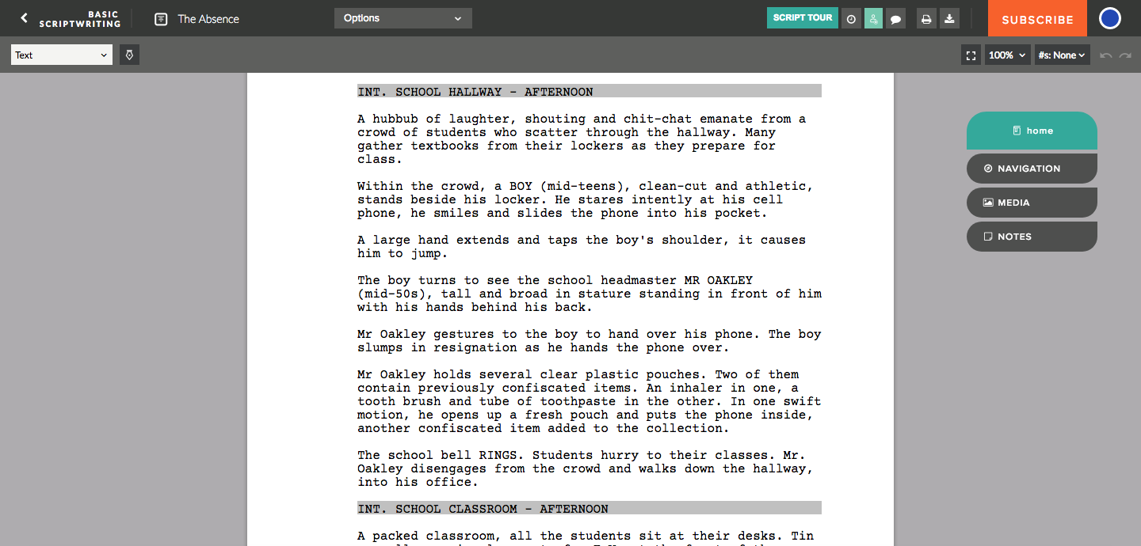

Image: Celtx

**2.1 Exercise 2**

**Screenplay quiz**

Read through the document titled ‘Duffy formatting example” on Google Classroom, which explains screenplay formatting. Then, in groups answer the following questions:

1. A scene takes place inside a Hilton hotel at night, which of the following scene headings is in the correct format?
2. EXT. HILTON HOTEL - NIGHT
3. INT. HILTON HOTEL - DAY
4. INT. HILTON HOTEL - NIGHT
5. Which tense accurately describes how action should be written in a screenplay?

1. Past tense: John **jumped** around.
2. Present tense: John **jumps** around.
3. Future tense: John **will** **jump** around.

1. Which format should be used when a new character’s name first appears?
2. Lower case
3. UPPER CASE
4. It doesn’t matter

1. Why is **(CONT’D)** sometimes used when a character is talking?
2. Because there is a break in dialogue and a new character is speaking
3. Because there is a break in dialogue but the same character is speaking
4. Because there is a break in dialogue and two characters are speaking at the same time

1. The following appears on the third page:

JAKE

(Weeping)

Rules, so many rules.

Putting the word ‘Weeping’ in brackets just below a character’s name is a technique

called **parenthesis**. When should parenthesis be used in a screenplay?

1. When a character is acting in a specific manner when speaking
2. When a character performs an action
3. When a new character is speaking

1. Which font is the industry standard for screenplays?
2. Times New Roman
3. Comics Sans
4. Courier
5. When writing a screenplay, every page apart from the first page must be numbered. Which side of the page should the page number go?
6. Upper left hand corner
7. Upper right hand corner
8. Bottom left hand corner
9. To indicate a different action is occurring in the same location, a word is added at the end of the scene heading. Which scene heading is in the correct format to indicate time has passed?
10. EXT. MOJAVE DESERT - DAY - LATER
11. EXT. MOJAVE DESERT - DAY - CONTINUOUS
12. EXT. MOJAVE DESERT - DAY - CONT’D
13. To begin and to end a screenplay two separate transitions are used, which two are the correct transitions?
14. CUT TO: to begin the screenplay and CUT FROM: to end the screenplay
15. MORE: to begin the screenplay and MORE: to end the screenplay
16. FADE IN: to begin the screenplay and FADE OUT: to end the screenplay
17. **Screenplay structure**

A screenplay is a story after all and as such it tends to be split into three sections; a beginning, a middle and an end. You might be familiar with the following terms:

* The beginning is the **introduction**
* The middle is the **build-up**
* The end is the **resolution**

Below is a sentence demonstrating the three-act structure:

*A horse walks into a bar, the bartender asks “Why the long face?”. The horse doesn’t respond because it’s a horse and horses don’t understand the human language. The horse gallops out of the bar.*

*A horse walks into a bar.* This is the **introduction**, this introduces the location as well as the protagonist. In this example, we are introduced to the protagonist (the horse) and the location (the bar).

*The bartender asks “Why the long face?”*. This is the **build-up**, this is where a confrontation is made. In this example, the bartender confronts the horse.

*The horse doesn’t respond because it’s a horse and horses don’t understand the human language. The horse gallops out of the bar*. This is the **resolution**, this is where the story has its closure. In this example, the horse doesn’t respond to the question and leaves the bar.

**3.1 Exercise 3**

**A three-act sentence**

E3, Q1: In your groups write a sentence that includes an **introduction**, **build-up** and **resolution**. You can think of an original story or draw from jokes, adverts and/or short stories.

1. **Background story**

Every screenplay has **characters** and these characters will play a significant part in engaging your audience. Interesting characters are descriptive and have developed backgrounds. To achieve this, you may ask questions and answer them for each of your characters.

Here is an example of a character description and background for **Toy Story**:

**Character name:** Woody

**Age:** N/A

**Occupation:** Informal leader ofAndy’s toys.

**Family members and/or significant others:** Andy (friend), Buzz Lightyear (friend).

**Personality traits:** Leader, intelligent, courageous and loyal.

**Character history (where is he/she from?):** Woody is a toy based on a character with the same name from a 1950s children’s TV series called *Woody’s Roundup*.

**Highest level of education:** N/A

**Physical traits:** A 13.5 cm tall, slender talking cowboy doll, both brown "plastic" hair and eyes, fair "plastic" skin, rosy cheeks, pull string on his back with a white loop attached to it.

**Biggest motivator:** Being Andy’s favourite toy.

**Biggest fear:** No longer being Andy’s favourite toy.

**Things he/she likes:** Spending time with Andy, checkers, safety, his friends, Bo Peep, victory.

**Things he/she dislikes:** Toys losing their owners, danger, losing his hat, Buzz Lightyear (formerly), his arm breaking, lies.

**4.1 Exercise 4**

**Creating a character**

E4, Q1: In your pairs/groups, use the character building template below to create a character description and background for one or two characters. You can use well-known characters or start thinking about the kind of characters you would like to have in your film. (Tip: you may want to create characters for your film!)

|  |
| --- |
| **Character 1 name**:  **Age:**  **Occupation:**  **Family members and/or significant others:**  **Personality traits:**  **Character history (where is he/she from?):**  **Highest level of education:**  **Physical traits:**  **Biggest motivator:**  **Biggest fear:**  **Things he/she likes:**  **Things he/she dislikes:** |
| **Character 2 name:**  **Age:**  **Occupation:**  **Family members and/or significant others:**  **Personality traits:**  **Character history (where is he/she from?):**  **Highest level of education:**  **Physical traits:**  **Biggest motivator:**  **Biggest fear:**  **Things he/she likes:**  **Things he/she dislikes:** |

1. **Glossary**

|  |  |  |  |
| --- | --- | --- | --- |
| **English** | **Español** | **Français** | **Deutsch** |
| Character background | La ficha del personaje | La fiche personnage | der Hintergrund |
| Build-up | El desarrollo | El développement | der Aufbau |
| Font | La fuente | La police | die Schriftart |
| Introduction | El planteamiento | L’introduction | die Einleitung |
| Parenthesis | El paréntesis/  La acotación | La parenthèse/  la didascalie | die Klammern |
| Resolution | El desenlace | Le dénouement | die Auflösung |
| Screenplay | El guión | Le scénario | das Drehbuch |
| Scene heading | El encabezado de escena | Le titre de séquence | der Szenentitel |
| Protagonist | Protagonista | Protagoniste | der Protagonisten |
| Antagonist | Antagonista | Antagoniste | der Antagonisten |
| Dialogue | Diálogo | Dialogue | der Dialog |
| Action | Acción | Action | die Handlung |
|  |  |  |  |
|  |  |  |  |
|  |  |  |  |
|  |  |  |  |
|  |  |  |  |

1. **Self-assessment**

After completing the four exercises, tick the column that best represents how you feel about the following statements:

|  |  |  |  |
| --- | --- | --- | --- |
|  | **Not at all confident** | **Nearly there** | **Very confident** |
| 1 I have an idea on how a screenplay translates onto the screen by reading a scene in screenplay format. |  |  |  |
| 2 If I watch a scene play out on the screen I have an idea of how the original script would look like. |  |  |  |
| 3 I am familiar with the key elements of a screenplay: main characters (protagonist, antagonist), dialogue, action and scene. |  |  |  |
| 4 I am aware of the three-act structure (introduction, build-up and resolution) in order to create a story. |  |  |  |
| 5 I know how to create an interesting character by asking and answering the character questions to provide a background. |  |  |  |

1. **References**

*Toy Story*. (1995). [film] Directed by J. Lasseter. Hollywood: Walt Disney Pictures.

Whedon, J., Stanton, A., Cohen, J. & Sokolow, A. (1995) *Toy Story Screenplay.* Hollywood: Walt Disney Pictures.

*Toy Story - Mrs. Nesbitt*. [video] Available at: https://www.youtube.com/watch?v=D5m33zK6ZlA [Accessed 20 Dec. 2018].

Celtx. (2018). Canada: Celtx Inc.

Duffy, M. (2017) *Duffy formatting example*. London: University of Roehampton.

Fandom. (2018). *Woody*. [online] Available at: http://disney.wikia.com/wiki/Woody [Accessed 20 Dec. 2018].

**8. Solutions**

**1. C**

**2. B**

**3. B**

**4. B**

**5. A**

**6. C**

**7. B**

**8. A**

**9. C**