

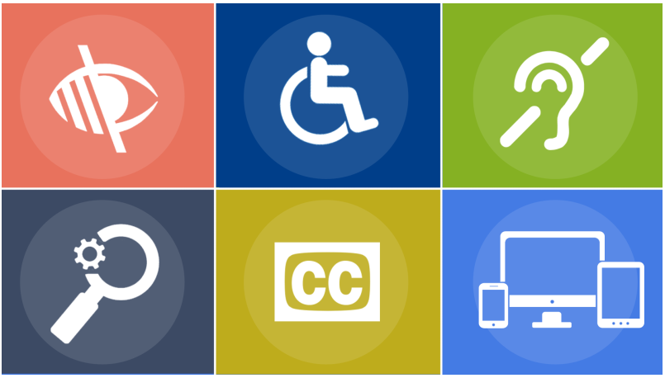

Image: Third Door Media

**Connecta**

**LEARNING PACK 1 | ACCESSIBLE FILMMAKING**

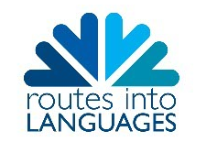



**Contents**

1. Access services
   1. Exercise 1 1

1.2 Dubbing 1

1.3 Subtitling 1-2

1.4 Subtitling for the hard of hearing 2-3

1.5 Sign language 3-4

1.6 Audio description 4

1. Accessible filmmaking

2.1 Exercise 2 5

2.2 Exercise 3 5

2.3 Subtitles for the deaf and hard of hearing (SDH)/Subtitles 6

2.4 Audio description 6

2.5 Sign language 7

2.6 Exercise 4 7

1. Suggested viewing 8
2. Glossary 8-9
3. Self-Assessment 9
4. References 9-10
5. **Access services**

**1.1 Exercise 1** In order to understand what access services mean, read each description, watch the clip [**Let it go - Multilanguage Sequence**](https://www.youtube.com/watch?v=OC83NA5tAGE)and answer the following questions:

**1.2 Dubbing** replaces the original dialogue of a film with a different language. Viewers who do not understand the original language of the film would use this service to *access* the film. This method is particularly used by children all over the world as they cannot read the next type of access services, subtitling.

E1, Q1: Are the voices synchronised with what is happening on screen?

E1, Q2: How does this make you feel as a viewer?

**1.3 Subtitles** are the written translation of the original dialogue of the film. They usually appear at the bottom of the screen in synchrony with the dialogue. Viewers use subtitles if they do not understand the original language of the film.

Search for the following clip on YouTube and answer the questions below:

* Cinema Paradiso 1988 (Original version) English subtitles

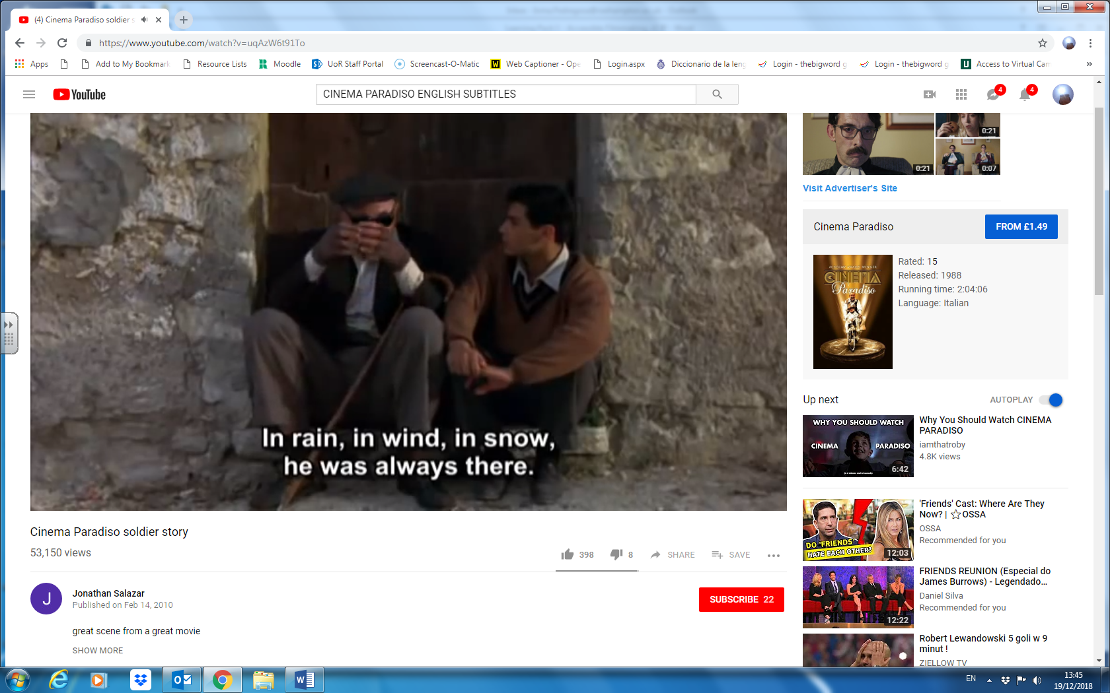

Image: Cinema Paradiso, Palace Pictures Classified

E1, Q3: Can you follow the film by reading the subtitles? If you can’t, why not?

E1, Q4: Can you see what is happening in the images while you are reading?

**1.4 Subtitles for the deaf and hard of hearing (SDH)** are similar to subtitles, but they are usually in the same language as the original dialogue of the film. They also include extra information to determine which character is speaking; whether the character is speaking in a happy, sad or angry tone; which sound effects there are (e.g. a telephone rings, a bomb explodes), or which music is being played. Typically, people who are deaf and hard of hearing would use this service, although other people may also find it useful.

Watch the clip titled ‘Shrek 2’, available via the Accessible Filmmaking section on Google Class, and answer the question below:

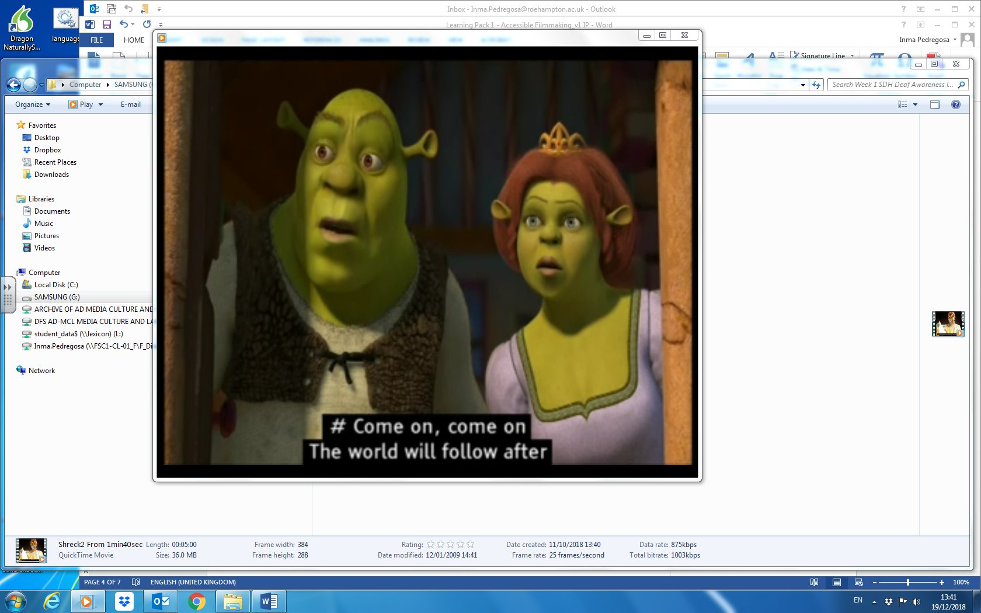

Image: Shrek 2, Universal Studios

E1, Q5: Why do you think sounds and music have been added?

**1.5 Sign language** is a way to communicate using a combination of hand shapes, gestures, facial expressions and body language. Mainly, Deaf people would use this service.

Watch the following clip and answer the questions below: [BBC News](https://www.youtube.com/watch?v=WDOp23R2Fqc)

E1, Q7: Where is the person signing on screen?

E1, Q8: Can you see what is happening in the images while watching the person signing?

**1.6 Audio description** describes the images when there is time in-between the original dialogue of the film. It is added as an audio track usually after the film has been made. People who are blind and partially sighted would use audio description.

Search for the following clip on YouTube and answer the questions below:

* Pirates of the Caribbean On Stranger Tides Audio Described (AD) Trailer

First of all, close your eyes and listen to the clip. Then, open your eyes and watch the clip again. Now answer the questions.

E1, Q9: Was the experience different? How?

E1, Q10: What is being described?

1. **What is accessible filmmaking?**
   1. **Exercise 2**

E2, Q1: There are four stages of the filmmaking process. Select which process matches each description:

**Distribution Pre-production Post-production Production**

1. ……………………………………. is the planning stage, which includes script-writing, story boarding, casting actors, finding locations and creating a production schedule (see unit on ‘screenwriting’).
2. ……………………………………. is when the film is recorded (see units on ‘acting for the camera’ and ‘shooting').
3. ……………………………………. involves editing the film, adding music, titles or graphics (see units on ‘editing’ and ‘adding sound and music’).
4. ……………………………………. is the stage when the film is being prepared for delivery to the audience.

Access services (dubbing, subtitles, subtitles for the deaf and hard of hearing, sign language, audio description) are often created during the distribution stage of the filmmaking process. However, an accessible filmmaking approach integrates translation and accessibility earlier in the process to improve the experience of viewers who use the services.

**2.2 Exercise 3** The following clips show examples of accessible filmmaking. The access services have been considered before the distribution stage of the filmmaking process. In order to understand the importance of accessible filmmaking, watch the clips and answer the following questions:

**2.3 Subtitles for the deaf and hard of hearing (SDH)/Subtitles**

Watch the clip titled ‘Extract from Interview with Amelia Cavallo’, available under the Accessible Filmmaking section of Google Class.

E3, Q1: Where is the subtitle on screen?

E3, Q2: Is it where subtitles are usually positioned?

E3, Q3: Does the subtitle draw your eye to the focus point of the image?

**2.4 Audio description**

Watch this extract from [Notes on Blindness](https://vimeo.com/84336261) (0:00 – 01:19)

E3, Q4: Read the list below. Which do you think are most important for the viewer to understand the narrative? Put in order of importance:

**Sound effects Music Dialogue**

1. ………………………………………………
2. ……………………………………………..
3. ……………………………………………..

Watch the clip titled ‘Notes on Blindness with audiodescription’ available under the Accessible Filmmaking section of Google Class, and listen to the audiodescription.

E3, Q5: Think about where the audio description is positioned in relation to the elements listed above. Is there enough space to describe the image?

**2.5 Sign language**

Watch this extract from [The End](https://www.bslzone.co.uk/watch/zoom-focus-end/) (0:00 – 3:00) and answer the following questions.

E3, Q6a: At what stage(s) of the filmmaking process would sign language need to be considered?

**Distribution Pre-production Post-production Production**

E3, Q6b: Please explain your answer.

**2.6 Exercise 4**

Have you given a thought about the story you are going to work on? Have you thought about the languages you are going to be using?

Think about which of the services above you are going to be using and how and when would you incorporate it.

E4, Q1a: Access service(s):

E4, Q1b: How and when would you incorporate it:

1. **Suggested viewing**

* Notes on Blindness: <https://vimeo.com/84336261>
* Joining the Dots: <https://vimeo.com/50824166>

English subtitles: <https://vimeo.com/64222807>

Spanish subtitles: <https://vimeo.com/51675746>

* The End: <https://www.bslzone.co.uk/watch/zoom-focus-end/>

1. **Glossary**

|  |  |  |  |
| --- | --- | --- | --- |
| **English** | **Español** | **Français** | **Deutsch** |
| Accessible Filmmaking | Cine accesible  (producción cinematográfica accesible) | Cinéma accesible  (production cinématographique accesible) | Barrierefreies Filmemachen |
| Audiodescription | Audiodescripción | L’audiodescription | Die Audiodeskription |
| Blind | Ciego/a | Aveugle | blind |
| Deaf | Sordo/a | Sourd/e | taub/gehörlos |
| Dubbing | El doblaje | Le doublage | die Synchronisation |
| Editing | El montaje | Le montage | das Editieren |
| Filmmaking | La cinematografía/  El cine | La réalisation/  Le Cinéma | das Filmemachen |
| Hard of hearing person | La persona con dificultades de audición | Malentendant/e | der/die Hörgeschädigte |
| Narrative | La Narrativa | Le récit | die Geschichte |
| Partially-sighted person | La Persona con dificultades visuales | Malvoyant/e | der/die Sehbehinderte |
| Preproduction | La preproducción | La préproduction | Vorproduktion |
| Production | La producción | La production | Produktion |
| Postproduction | La postproducción | La postproduction | Postproduktion |
| Screenplay | El guion | Le scénario | das Drehbuch |
| Script | El guion | Le script | das Manuskript |
| Subtitling for the deaf and hard of hearing | Subtítulos para personas sordas | Sous-titrage pour personnes malentendantes | Untertitel für Hörgeschädigte |
| Shooting | El rodaje | Le tournage | das Filmen/  die Dreharbeiten |
| Sign | Signar | Signer | die Gebärdensprache |
| Storyboard | El guion gráfico | Le scénarimage | das Storyboard |
| Viewer | Telespectador/a  Espectador/a | Téléspectateur/trice  Spectateur/trice | der Zuschauer/  die Zuschauerin |

1. **Self-assessment**

After completing the four exercises, tick the column that best represents how you feel about the following statements:

|  |  |  |  |
| --- | --- | --- | --- |
|  | **Not at all confident** | **Nearly there** | **Very confident** |
| 1 I have an idea of what access services are and why they are important. |  |  |  |
| 2 I have an understanding of the stages of the filmmaking process. |  |  |  |
| 3 I am aware of when access services are usually provided during the filmmaking process. |  |  |  |
| 4 I am aware of the advantages of considering access services during all stages of the filmmaking process. |  |  |  |
| 5 I have ideas about how to incorporate an access service into my story. |  |  |  |

1. **References**

# Walt Disney Animation Studio (2014) Disney's Frozen - "Let It Go" Multi-Language Full Sequence. Available on YouTube at <https://www.youtube.com/watch?v=OC83NA5tAGE>

* Shrek 2 (2004) directed by Andrew Adamson, Conrad Vernon and Kelly Asbury produced by Dreamworks.

# BBC News (2015) BBC News at One - 14 Aug 2015 - Labour Leadership Candidacy _feat_ BSL Signer. Available on Youtube at <https://www.youtube.com/watch?v=WDOp23R2Fqc>

* In Conversation with Amelia Cavallo (2018) Directed by Kate Dangerfield and Amy Neilson Smith. Funded by Arts Council England.
* Notes on Blindness (2014) Directed by Peter Middleton and James Spinney. Produced by Archers Mark.
* The End (2011) Directed by Ted Evans. Produced by Defeye Films.
* Joining the Dots (2012) Directed by Pablo Romero Fresco. Produced by Sunday Films.
* Romero-Fresco, Pablo and Louise Fryer (forthcoming) Accessible Filmmaking Guide, London: British Film Institute.